In Car Navigation System
- This system is only engaged in missions
- It’s only engaged when there is a specific point that the user is directed towards (e.g., the next collectible, locator, NPC, waypoint, etc.)
- Throughout the world on key intersections Animated Navigational arrows will appear. The arrows point in the general direction of the player’s current objective. All intersections are flat, so a common in-game animation can be used, e.g.:

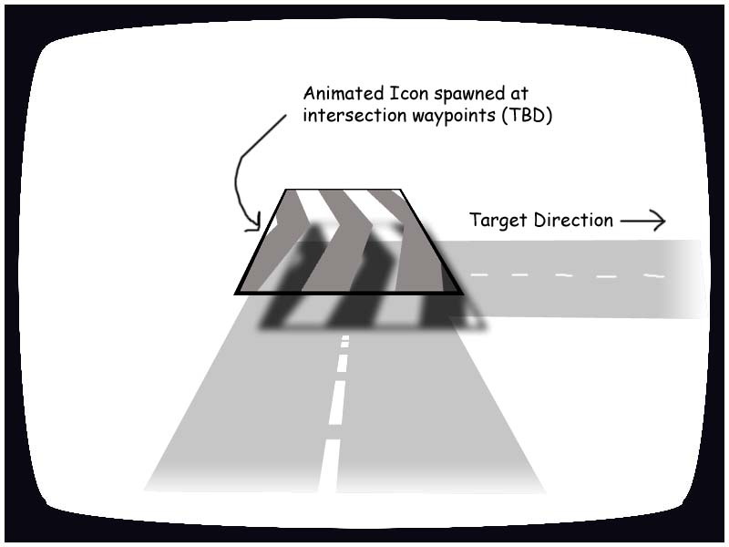

- The road data will include data on whether a path is a shortcut, and which intersections should show the animation
- There may be many intersections between the player and their objective. So the algorithm will include something like the following steps:
  - Find the road piece nearest to the user character
  - Find the road piece nearest to the destination point
  - Traverse the level in both directions to find the shortest [non-shortcut] path between these pieces of road
  - Mark the intersections with a directional animation
  - Mark at least one intersection in “the wrong way” from the shortest route. E.g., if you are directed to the Kwik-E-Mart and turn right out of the Simpsons driveway, you would realize you are going the wrong way when you hit the next intersection
- The player can turn this function off in the pause menu (Options - Settings - Intersection Navigation System on/off).

